Module Four Assignment

1. **Possible object** –

|  |  |  |
| --- | --- | --- |
| Object | Attributes | Methods |
| Bike | Color, Make, Model | Speedup, Apply Brakes, Service indicator |
| Customer | Name, id, CreditCard information | Request Service Appointment, Sell Bike ,  Purchase Bike |
| Sales Rep | Name, Empoyee Id, Sales Make this quarter | Sell Bike, Sell insurance, Update Book keeper about the stock |
| Onwer/Manger | Name, Number of employees, Number of stores owned | Hire new Employee,  Fire existing Employee,  Pay Salary |
| Book Keeper | Name, Employee id | Add sale record,  Delete sale record,  Add bike to inventory  Remove bike from inventory |
| Mechanic | Name, Employee id | Repair bike |
| Service helper | Name, Employee id | Assemble bike |

1. Actors –
   1. Customer
   2. Bookkeeper
   3. Mechanic
   4. Service helper
2. Use cases
   1. Buy a bike
      1. Actor - Customer
      2. Description – Buy a new bile
      3. Successful completion –
         1. Customer purchases a new bike
         2. Inventory is updated
         3. Sale record is entered
      4. Precondition – None
      5. Post condition- Update inventory
   2. Update the inventory
      1. Actor – Bookkeeper
      2. Description – Update the inventory list
      3. Successful completion –
         1. Inventory is updated
         2. Sale record is entered
         3. Bike count changed
      4. Precondition – Purchase request
      5. Post condition – Inventory is updated, notification sent to the owner
   3. Repair Bike
      1. Actor – Customer/Service Helper/ Bookkeeper
      2. Description – Repair a Bile
      3. Successful Completion –
         1. Customer bike is repaired
         2. Sale record is entered by the book keeper
         3. Service Helper repairs the bike
      4. Precondition – Service request has been scheduled
      5. Post Condition – Bike has been repaired
3. Use case diagram of the service request

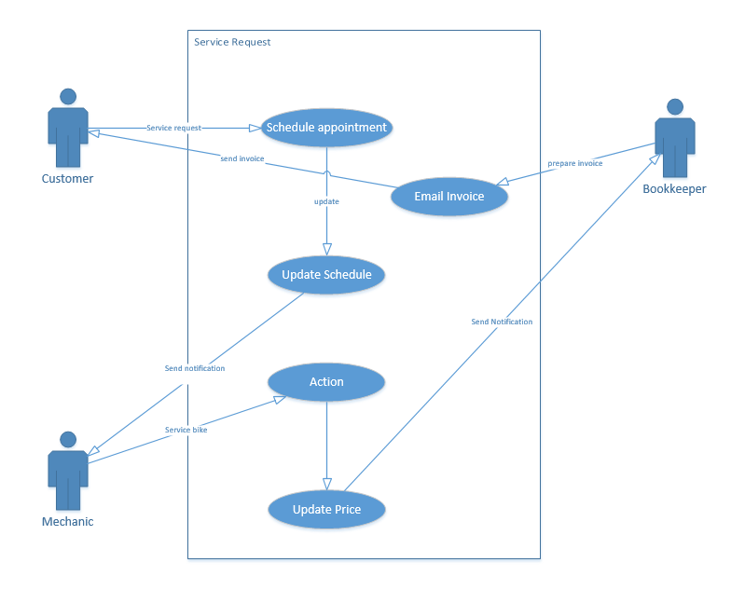

1. State transition diagram

